Functional specification

One Credit Engine – Modernization

Accounting

Version: 0.9

Change History

Date | Version | Revised chapters | Description | Changed by
2023-08-22 | 0.1 |  | Initial document created | Fredrik J
2023-08-30 | 0.9 |  | First main update | Fredrik J

Table of Contents
1 Introduction 4
2 New functionality 5
2.1 Organization structure vs legal enity. 5
3 Legal Entity model 7
3.1 Legal Entity 7
3.1.1 External Account Values 7
3.1.2 External Account Parts 8
3.2 Accounting Class 8
3.3 Accounting Ledgers 8
3.4 Accounting Rules 9
3.4.1 Accounting Events 9
3.4.2 Formula 10
3.4.2.1 Amount Type 10
3.4.2.2 Amount Group 10
3.4.2.3 Formula Condition 11
3.4.2.3.1 Conditions 11
3.4.2.3.2 Condition Values 12
3.4.3 Accounts 12
3.4.3.1 ChartOfAccount 12
3.4.3.2 PseudoAccountCOA 12
3.4.3.3 PseudoAccount 13
3.4.3.4 PseudoAccountExtparts 13
3.5 Legal Entity - Connection flow 13
4 General issues/areas 14
4.1 Translations 14

Introduction
This document is inteeded to cover the new Accounting domain at a high level.

New functionality
The accounting domain will be a separate microservice that will take care of all accounting related work. This includes the full configuration of needed structural data and all created bookings.
Other domains will provide accounting data for specific events via messages.
Messages will always contain all data that the accounting module may need to complete its work using booking rules defined in the accounting domain.
Portfolio must always be a part of every message. I.e. if another domain calls the AR domain and does not have any portfolio at all, a portfolio to be used must still be provided.
Or we must have logic in accounting domain (and other domains) that default to a specific, preset portfolio if portfolio is not provided by the “external” part at the call to our domains.

Organization structure vs legal enity.
The accounting setup will always be defined at the Legal Entity level which in turn is connected to an Organization Unit (OU) in a one-to-one relationship. I.e. an Organization Unit controls the accounting by using a specific Legal Entity. It is though possible to have an Organization Unit with no defined Legal Entity, if the OU is a child to another parent OU. If this is the case then the logic will find a legal entity, connected to a parent OU at the nearest upper level in the hierarchy that has a legal entity defined.
Example of organization structures:
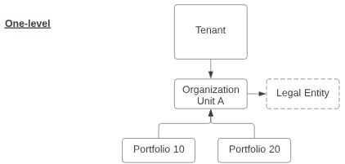
Only one legal entity is used for handling all accounting.

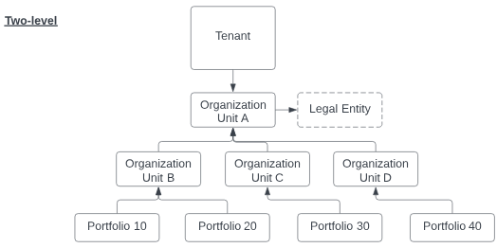
Only one legal entity is used for handling all accounting. Organization units B,C andD will all use the same legal entity defined for organization unit A.
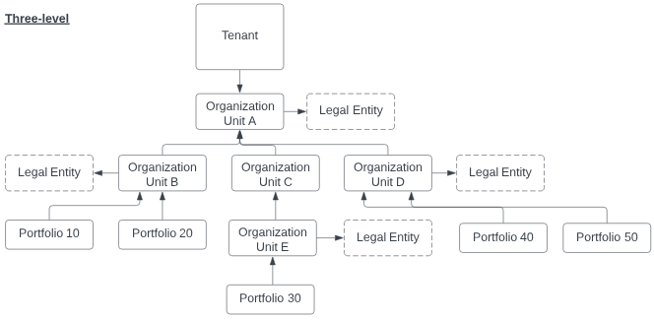
Three legal entities will be in effect to handle the accounting.
- Organization unit B will use its own legal entity.
- Organization unit D will use its own legal entity.
- Organization unit E will use its own legal entity.
- Organization unit Cwill use the legal entity from its nearest parent Organization A.

Legal Entity model
The legal entity model is shown in the embedded pdf file below.
The legal entity model, its hieararchy and charchteristics for each part is described in the sections below.

Legal Entity
The top level for accounting.
The legal entity controls all accounting actions for all accounting events received from the different domains that use the accounting module.
Is always connected to one Organization Unit (OU).
Holds general properties such as:.
- Legal Entity ID
- Legal Entity Name
- Jurisdiction
- Registration Number
- Fiscal Year
- GLI Number Serie
- Accounting Currency
- Revaluation

External Account Values
List of all available base records in the contract domain that can be used in the external account string, that will be sent to an external General Ledger.
Following values must be included in a specific message from the contract domain:
- Company/Tenant
- Organization Unit
- Portfolio
- Product
- Agreement Number
- Agreement Line
- Customer identity
- Cost Center
- Cost Unit
- Currency Code
- Asset Number
- Serial Number
- Reg. Number
- Tax Code
- Table 1 (Contract level)
- Table 2 (Contract level)
- Table 3 (Contract level)
- Text 1 (Contract level)
- Text 2 (Contract level)
- Text 3 (Contract level)
- Table 4 (Contract line level)
- Table 5 (Contract line level)
- Table 6 (Contract line level)
- Text 4 (Contract line level)
- Text 5 (Contract line level)
- Text 6 (Contract line level)

External Account Parts
The actual fields from external account values that will be used by the specific legal entity.
The place and length for each included field will alse be set at this level
The fields that are set here will be available as account parts for specific pseudo accounts that will be used in the chart of accounts.
I.e. a specific external account part may or may not be used for a specific pseudo account.
Main attributes:
- External Account Part ID
- Part Number (order)
- Name
- Length

Accounting Class
Accounting class is a key element that controls the bookings for a specific segment/domain for different events/actions.
Connected to Legal Entity.
Initial accounting classes are:
- PF-Contract
- AR Invoicing
- AR Payment
- AP Invoicing
- AP Payment
A layer that is used to handle configuration for specific domain actions.
This will make the solution capable of getting messages from external systems that wants to use the AR domain for invoicing and accounting for whatever purpose that may be needed.
For example, if someone wants to use our AR invoicing domain but for data that has nothing to do with contracts (e.g. pure service or subscriptions). In order to use the accounting domain and set up booking rules for that specific scenario, the accounting class AR Invoicing will be used.
Attributes:
- Id
- Name
- Legal Entity ID

Accounting Ledgers
Defines in which ledger an Accounting Class will act.
Connected to Accounting Class.
Facilitates the use to book in different ledgers if needed (e.g. Normal / US GAAP etc).
I.e. each accounting ledger will have its own set of pre-defined accounting rules, setup by each customer.
Attributes:
- Id
- Name
- Accounting Class ID

Accounting Rules
Controls how the actual booking shall be created, using an accounting event, accounting formula, account and debit/credit definition.
Connected to an Accounting Ledger.
Attributes:
- ID
- AccountingLedgerID
- FormulaID
- AccountingEventID
- Debit/Credit

Accounting Events
Connected to Accounting Rules.
Events that creates bookings.
Attributes:
- ID
- Name
- BookingDate
0 = CalculationDate. The execution date of a booking
1 = EventDate. When the booking is considered in effect – e.g. a specific settlement date.
Following events need to be covered in respective domain.
PF-CONTRACT:
- Activation
- Assignment
- Undo Activation
- Payment change
- Interest change
- Residual Value change
- Split Contract line
RECEIVABLES:
AR Invoicing
- Agreement invoicing
- Manual nvoicing
- Settlement invoicing
- Termination invoicing
- Reminder invoicing
- Credit invoice
- Change invoice
- Write off
AR Payment
- Normal
- On Account
- Unallocated / unknown
- Repayment
- Change
PAYABLES:
AP Invoice
- Registration
- Change
AP Payment
- Payouts
ACCOUNTING:
- Monthly Booking

Formula
The main building block for accounting.
Is connected to Accounting Rules, PseudoAccountCOA ,Amount Type and Formula Conditions.
A formula will use amount types to understand where/when to retrieve the data.
Attributes:
- ID
- Name
- Description
- AmountTypeID
- FormulaConditionID
- PseudoAccountCOAID

Amount Type
List of all available base values that can be used in formulas and retrieved from messages.
Connected to Formula.
Attributes:
- ID
- Name
- AmountGroupID
Example:
- Purchase Price
- Fixed Asset Value
- Total Plan Amortization
- Total Plan Interest
- Total Plan Rent
- Invoice Total Amount
- Invoice Total Net Amount
- Invoice Total VAT Amount
- Invoice Amortization
- Invoice Interest
- Invoice Added Cost
- Invoice Service
- Invoice Fee
- Invoice Rounding
It must be possible to add new amount types both by TietoEvry and by external parts.
For example, adding new amount type Electricity in Receivables domain and then also in the Accounting domain which can then find the amount and include it in a formula definition.

Amount Group
The amount group defines the source for where to retrieve data.
Connected to Amount Type.
Attributes:
- ID
- Name
Available options:
0 = Message
1 = Accrual handling (create/update)
2 = Monthly update

Formula Condition
Formula conditions can be added to a specific formula in order to overrule the standard account defined for a formula if specific conditions are met.
Linked to Formula.
Formula condition is set by defining a condition and a condition value.
Attributes:
- ID
- Name

Conditions
The specific condition to be used in a formula.
Linked to Formula Condition, Condition Values and PseudoAccountCOA.
Attributes:
- ID
- Level/Condition No
Execution order for multiple search conditions
- FormulaConditionID
- ConditionValuesID
- PseudoAccountCOAID
- Value
The comparison value for a specific Condition Value.
- Operator
Condition operator: And / Or
Two examples of use of formula with conditions are show below:
1. Fixed Asset Value
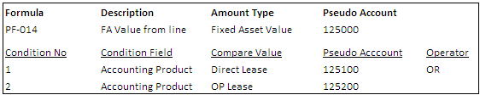
If no condition is valid, booking on account 125000 will be applied.
If one of the condition numbers is valid, the account for that condition will be applied.
2. Charge Code
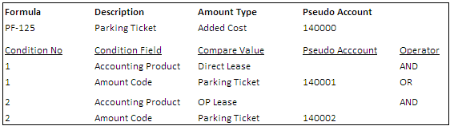
If no condition is valid, booking on account 140000 will be applied.
If one of the condition numbers is valid, the account for that condition will be applied.

Condition Values
The actual message attributes that can be used as condition values.
Attributes:
- ID
- Name
Following values will be available:
- Accounting Product
Same as Transaction Type in old PF. Will be set on the Product which will make it possible for multiple products to use the same accounting configuration.
- Invoice Type
The name of the specific type in the message.
Which type that is in effect is controlled by the accounting event.
Example:
  - Normal
  - ManualInvoice Type 1
  - ManualInvoice Type FJ
  - SupplierInvoice Type RK
  - SupplierInvoice Type Allan
- Added Cost
The name for a specific Added Cost.
- Payment Method
- VAT Name
Needed to set condition to book different VAT rates on separate accounts.

Accounts
Pseudo account is the internal denomination for the account to use when defining formulas.
Formulas are in turn used when setting up Accounting Rules which thus implicitly gets its pseudo account from the used formula.
A Pseudo Account may or may not use one or more external account parts. Which external account parts that are available is defined at the Legal Entity.

ChartOfAccount
A template with predefined headings and levels that can be used when setting up the accounting configuration. We will provide standardized template for different countries.
For example, one targeting US GAAP way of creating account structure and another that targets the Scandinavian market (which has a completely different set up).
A ChartOfAccount will be applied at the Legal Entity level which means that different accounting ledgers (is used), will have same setup of pseudo accounts that can be used for configuration.
Attributes:
- ID
- Name
- Description
- Order
- Depth
- ParentID

PseudoAccountCOA
A supporting link table between PseudoAccount and ChartOfAccount.
Used to keep track of the specific hierarchy for the pseudo accounts used in a specific Legal Entity.
Attributes:
- PseudoAccountCOAID
- AccountID
- COAID

PseudoAccount
The main account component.
Attributes:
- AccountID
- PseudoAccount
- Name
- External Account
The account to be used when exporting transactions to the external general ledger.
Can be the same as the PseudoAccount or different.
- Revaluation
Defines if the pseudo account shall be included in the revaluation process, when recalculating open balances to a new currency rate.

PseudoAccountExtparts
The external account parts that can be enabled for a specific pseudo account.
Connected to External Account Part (i.e. accounts parts set as available for the Legal Entity).
If one part is set as InUse, it will be included in external account string when bookings are created.
Attributes:
- ID
- Account ID
- External Account Part ID
- InUse (0=No; 1=Yes)

Legal Entity - Connection flow
An example of the flow between the different areas in the accounting domain is displayed in the document below.

General issues/areas

Translations
All base configuration areas must support translations to different languages.

